

How to take a test

Simply log-in to the system, which will take you to the dashboard. From here, select the ‘take a test’ box.

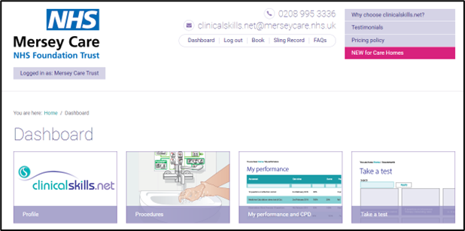
From here, select ‘local tests’

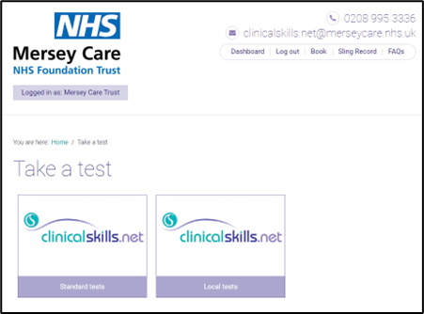

From here, you will see a list of tests within the category. Simply select the test you wish to take. You can also use the search bar to find the test you are looking for, then click ‘apply’.

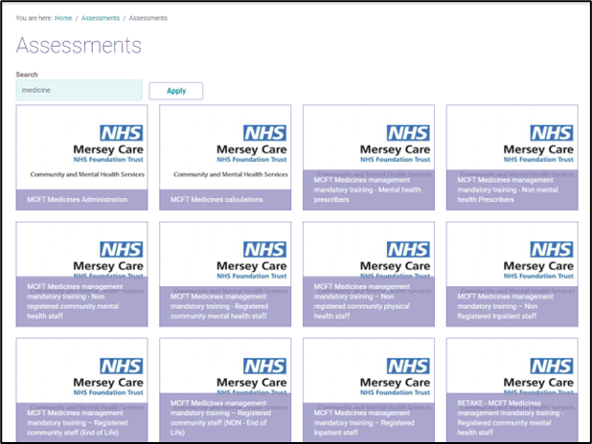
Once you have selected the test you are looking for, it will pull up a list of the procedures relating to that test, with hyperlinks to each. It is recommended that you familiarise yourself with these procedures before taking the test. Once you are ready, simply select ‘start your test’.

WE STRONGLY URGE YOU TO COMPLETE ALL RECOMMENDED PRE TEST READING
