RADAR Duty of Candour

Question if a duty of candour applies.
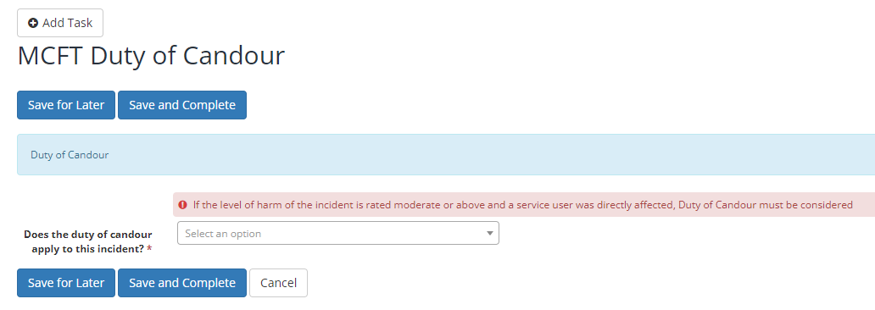

When the question ‘Does the duty of candour apply to this incident?’ – No is selected you will see a question appear ‘Why does duty of candour not apply.

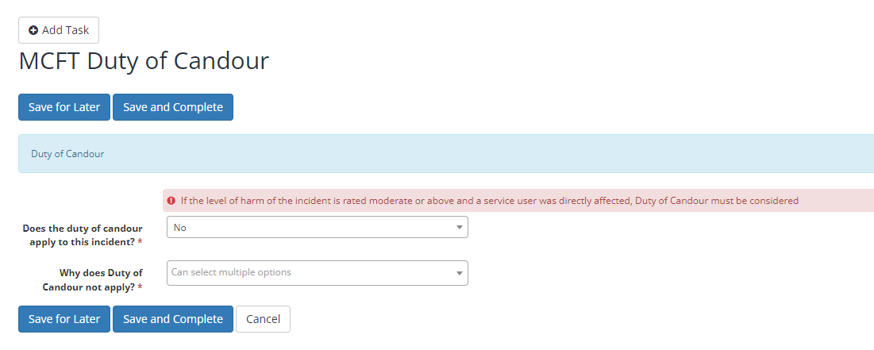

If ‘Yes’ is selected for the question ‘Does the duty of candour apply to this incident?’ you will see

All the questions from ‘Was verbal apology/Explanation provided to the service user/appropriate person? and down, depending on what you choosw will bring up another question. Please see further screenshots below.

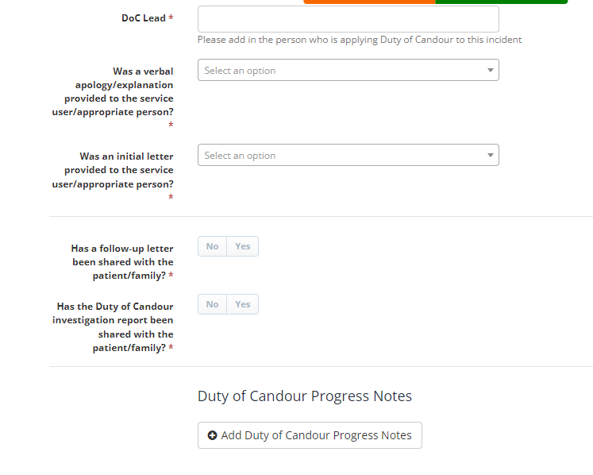

Verbal
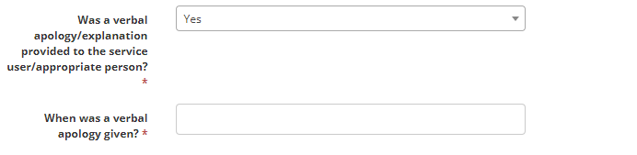
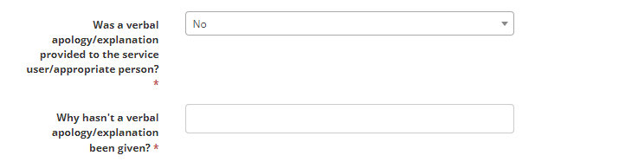
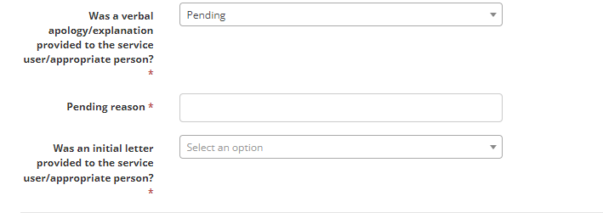

Written
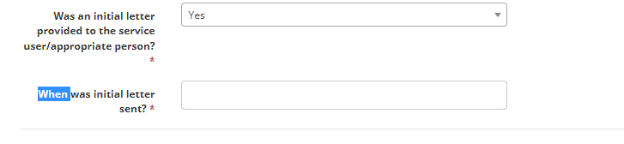
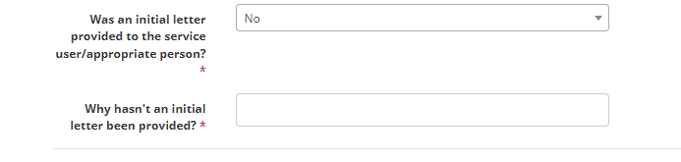
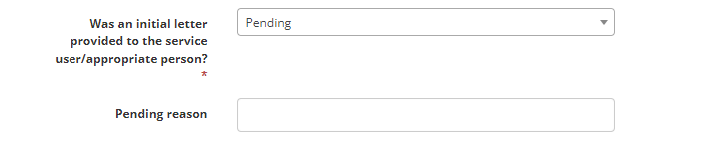
Follow Up letter
No
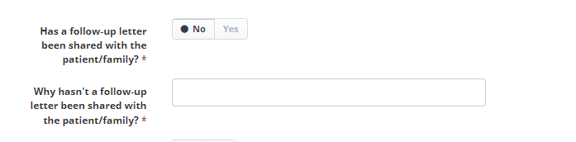
Yes
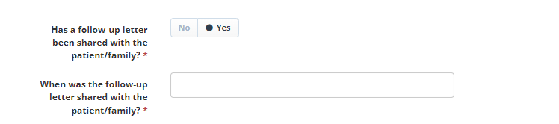
Investigation been shared with family
No
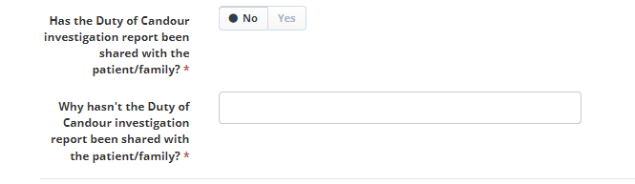

Yes
