How to Access ESR

This guidance document will help you with logging into ESR and how to complete e-Learning. Failure to correctly close an E-Learning package, will result in non-recording, and having to complete it again.
There are a several ways of accessing ESR from home, depending on the electronic device you are using which are detailed below.
A Work Laptop
Login to your laptop as usual and click on the icon below from your desktop. This will prompt you to enter a username and password or log in with a Smartcard.
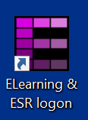
Personal Computer/ Laptop, iPad, Tablet or Phone
Login to your own personal computer or laptop, open Google Chrome or Microsoft Edge and type in https://my.esr.nhs.uk/ in the address bar.
In the top right corner, you will see ‘Login to ESR’. Click this and then enter your username and password onto the home page.
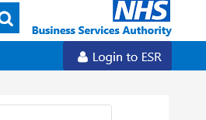

When first logging into ESR, your password will expire, and you will need to choose a new one. Please see below guidance on setting a new password.

ESR Password Guidance

When users change passwords the following rules will apply:  Password Item | New
Password Minimum Length | 12 Characters
Consecutive Failed Login Attempts | User accounts will be locked after three consecutive failed logon attempts.
Alphanumeric | Password must contain at least one letter and at least one number
Consecutive Passwords | User cannot change password to any of the last 5 passwords
Repeating Characters | Password must not contain repeating characters/numbers
Sequential Characters | Must not contain more than 3 sequential characters/numbers (both collating sequential and keyboard sequential) eg 123 or abc
Names Within Passwords | Must not contain real user name (first name or surname) or username

- Please remember - never share you’re ESR username and password with anyone, this username and password is unique to you, and you should always keep it private and confidential.
- Never write down or share your username and password
- Always ensure you log out of ESR when no longer using them system
- Never leave your device unattended while logged into 'My ESR'

If you need any help or support with logging into ESR please contact Workforce Systems Team on the below details:
0151 295 3292
elearning@merseycare.nhs.uk

Completing E-Learning Packages
When logged into ESR, your E-Learning requirements will be listed under My Current Self-Paced Enrolments and My Current Certifications.
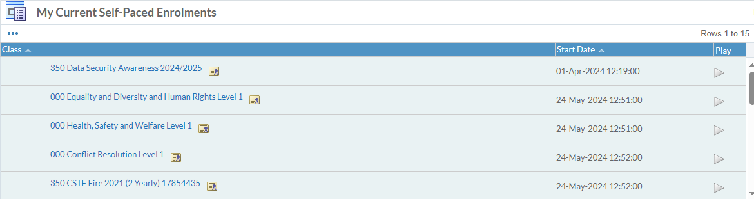
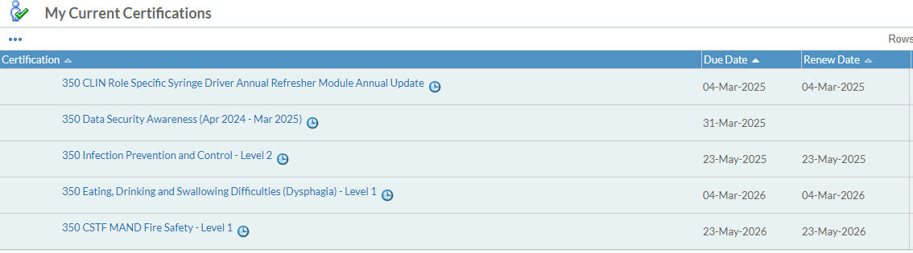
These are the courses you need to complete as part of your role. To complete these courses, click on the Play Symbol as shown in the green circle.

Once a course is completed you will see a version of the below screen. As you can see, the package is complete, and assessment passed. To exit this course, you need to click on the blue house located on the top right corner as shown below.
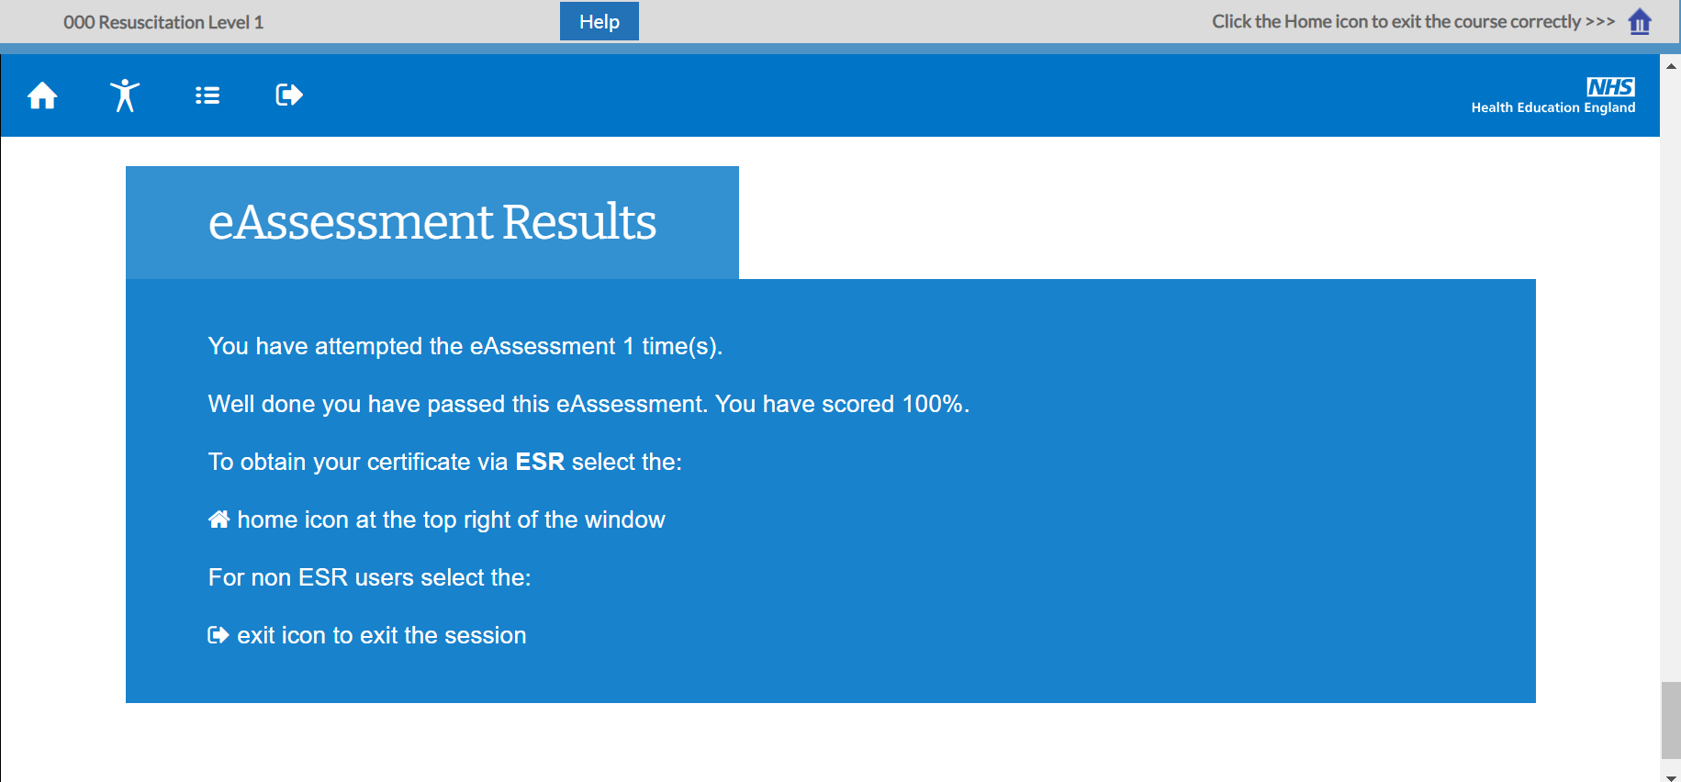
This is what records the completed package against your training history. If the course isn’t closed in this way, the completion wont record and you will be asked to complete it again.
For further information, a range of guides to help access and learn about ESR are also available on the link below; https://my.esr.nhs.uk/dashboard/web/esrweb/looking-for-help-

