Lifehouse, Units 4 – 5, Dempster Building, Summers Road, Brunswick Dock, Liverpool, L3 4BL, Venue Contact Number: 296 7733

Information on parking at Lifehouse from the Building Manager
You do not need to reserve a parking space at this venue, staff and visitors are to not park in the disabled bays unless they have a blue badge – which they must display.

If the car parks are full at the front and back of the building, the carpark opposite the gates on summers road can be used as an overflow

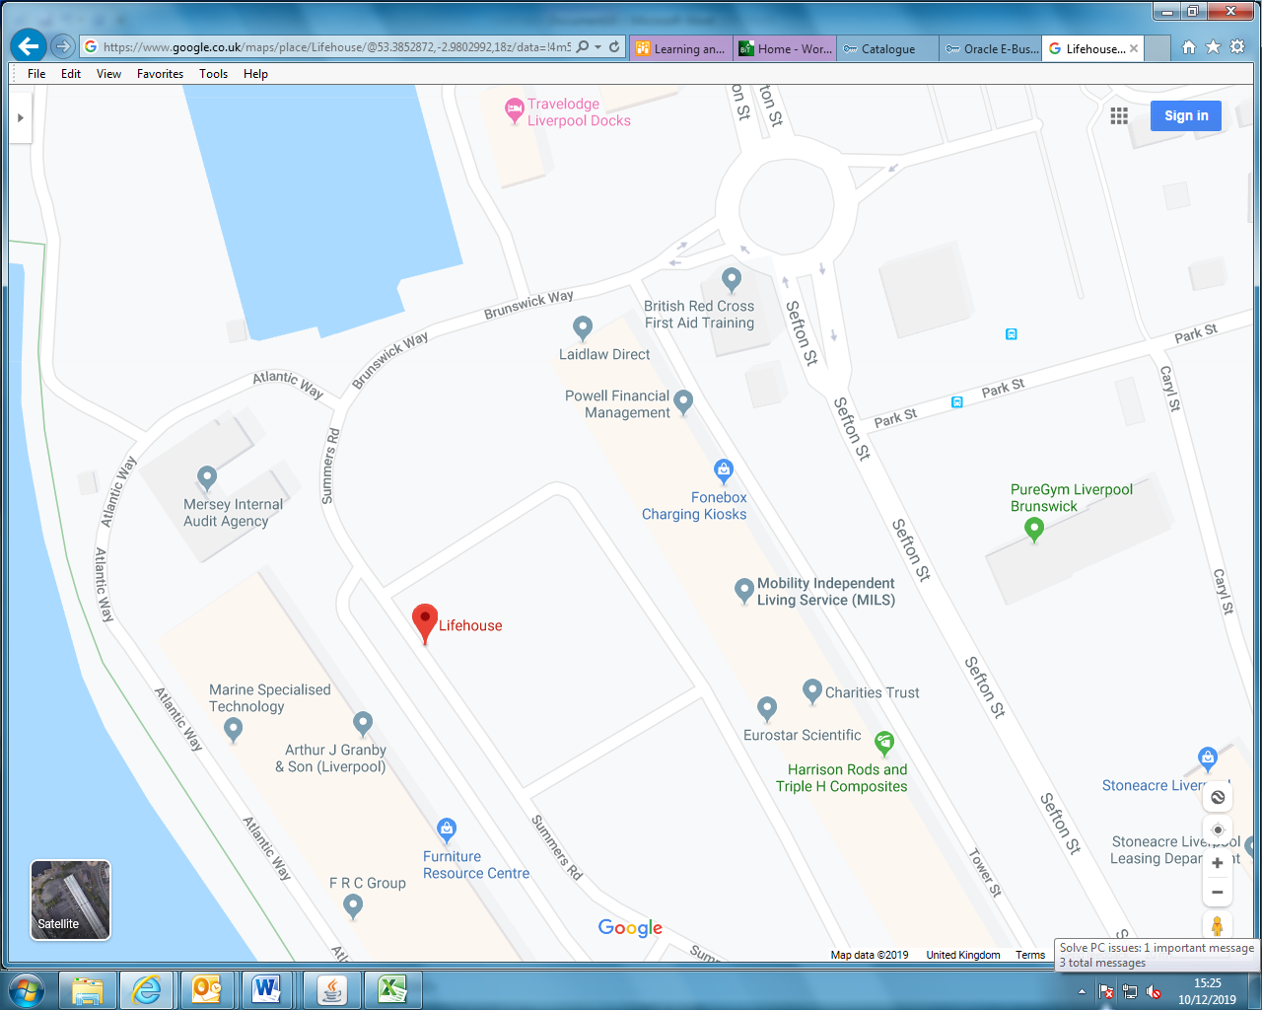

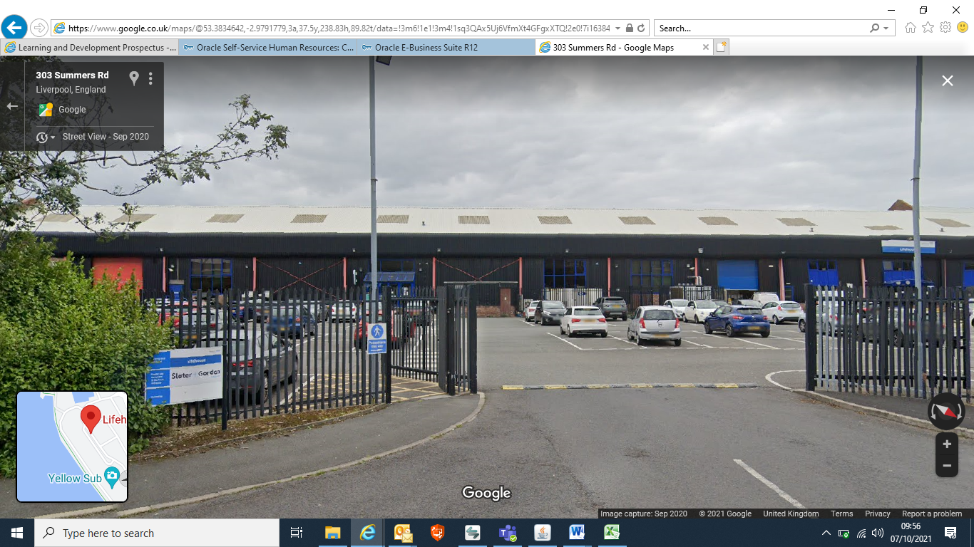

Car Park and Entrance are in front of the building and are accessed via Summers Road. Do not use the entrance on Atlantic Way.
Should you require a more detailed map access 1 of the following links.

www.streetmap.co.uk www.multimap.com

